When the Raspberry Pi's default system space is full and can no longer be used for installations, etc., and there is still space on the SD card that is not being used, the Raspberry Pi can be expanded.

Assuming that the size of a mirror is 4G, since the requirements of the mirror on the memory card is greater than or equal to 4G, but for more than 4G memory card, the Raspberry Pi's system is only utilised up to 4G, so there is such an operation as expansion.

1. Expansion steps:

Use the tool that comes with the Raspberry Pi to quickly mount all the SD card space on the Raspberry Pi and expand the system partition to the maximum capacity of the SD card.

**(1)**Open the **raspi-config** system configuration tool

sudo raspi-config

1. Select **Advancd Options**:

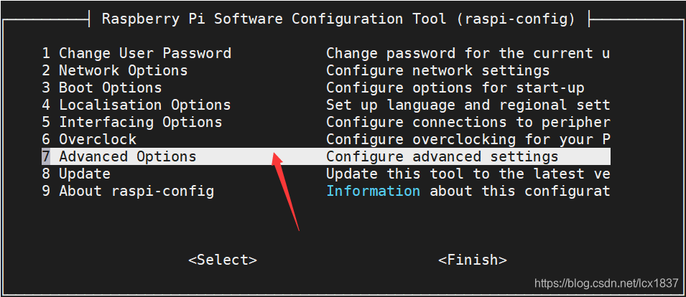

**(3)**Select **Expand Filesystem**

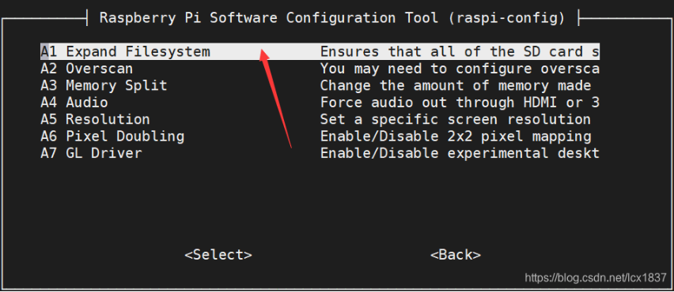

**(4)**OK

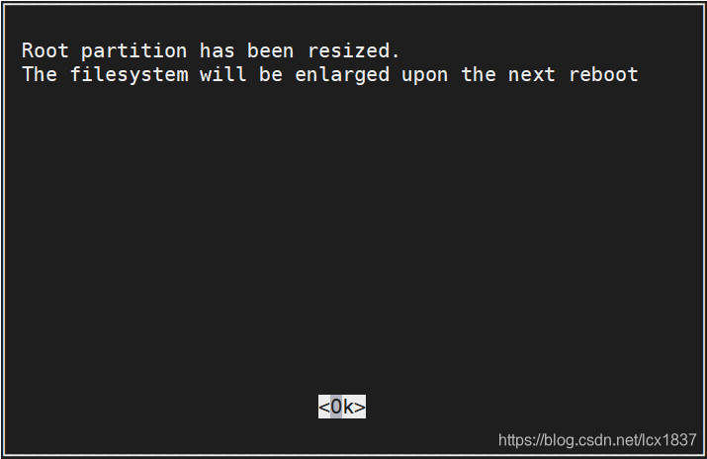

(5)Reboot Raspberry Pi